The Accuracy of Opinion Polling

**In modern society, opinion polls are widely used to measure public opinion, with questions being asked such as “do you favour a ban on smoking in public places?”. An opinion poll is an evaluation of public opinion on certain matters through questioning a representative group of people. Generally, these are carried out when various organisations want a political subject answered, in particular in the UK they are used when attempting to predict who will be elected in the next general election. Opinion polling can be a powerful yet dangerous tool, as it can misrepresent a certain party’s popularity. In this report, I will be discussing the reliability of opinion polling, comparing it to electoral results and using statistical analysis to come to a sound conclusion.**

**How Is Opinion Polling Conducted?**

**There are many ways in which opinion polling is carried out, the main ones being online polling, telephone polling, and door-knock polling.**

**One of the leading polling organisations YouGov conducts its opinion polls online. The organisation has gathered a panel of over 360,000 people. When a political question needs to be answered they fill the sample quota from this panel, these people are then asked to fill out an online survey** (Study.com, 2016)[6]**.**

**Another large organisation that conducts opinion polling in the UK is Ipsos MORI. This organisation uses telephone polling to evaluate public opinion. They use random-digit dialling so the panel is completely random, they assort the panel into weighted demographics in order to fulfil the sample quota** (Study.com, 2016)[6]**.**

**The most accurate way of polling is the use of “door- knock polls”. This is where individuals hired by polling organisations go from house to house and fill out surveys regarding political issues. This is the ideal way of gaining polling data as it reaches the broadest demographic, it also gains the most reliable data as people are more likely to share their true opinion when the survey is carried out in person. However, it is impractical and costly. It requires a lot of finance as well as manpower to reach the required sample quota, a significant amount more than online and telephone polling.**

**Online Polling**

**The use of online polling is extremely convenient; people can fill out polling surveys on the go, on their smart phone. The costs implicated with online polling are also extremely low, including costs for creating and maintaining a website. The cost per person reached appears to be even lower with an almost limitless reach of people to question. However, those questioned will in most cases be of a younger generation. The elderly may find it difficult to navigate their way through a computer in order to fill out a survey, hence this may skew the results of a poll as not all opinions will be recorded** (BBC News, 2015)[1]**. In order to resolve this, organizations put “weights” onto certain demographics. This is where demographic results are increased or decreased appropriately to gain a fair and accurate representation of the population.**

**In the 2015 general election, the polling organizations such as YouGov put weights onto different age categories, however these weights were not correct and they did not successfully represent the opinion of different demographics. The younger generations were over-represented skewing the polling results in favour of the Labour party. This was due to the voter samples containing a higher proportion of Labour supporters than in the general election** (Shakespeare, 2015)[5]**. Whereas the older generations were under-represented due to the incorrect weighting. This led to a lower show in support for the Conservative party, as opinion polls underestimated the number of older typically-Conservative voters in the country** (Clark and Perraudin, 2016)[2]**. This had the overall effect of making the 2015 online opinion polling results very inaccurate, it gave the impression that both Labour and the Conservatives were neck and neck, whereas in fact the Conservative party had a much stronger showing in the country than was predicted in the polls. This is shown in the figure 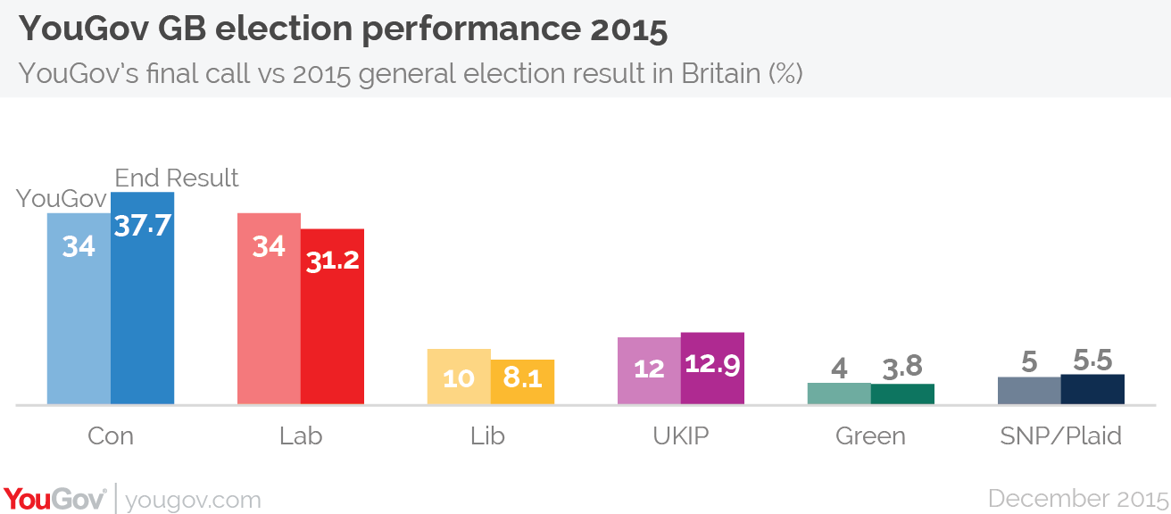below.**

Figure 1: YouGov Election Performance 2015 (Shakespeare, 2015)[5]

**Telephone Polling**

The use of telephone polling is extremely convenient. In modern society, most people carry a mobile phone around with them wherever they go. This means that a large number of participants respond to polling organisations within 10 minutes of being contacted. Furthermore, participants will respond to questions in their natural state, not having much time to question themselves about their answers. This results in true opinions being recorded with no outside influence. Mobile phones also reach a broad demographic, with even those in the older generations using them. This means that a broad demographic can be reached by polling organisations resulting in more reliable and accurate data (Ipsos-mori.com, 2015)[3].

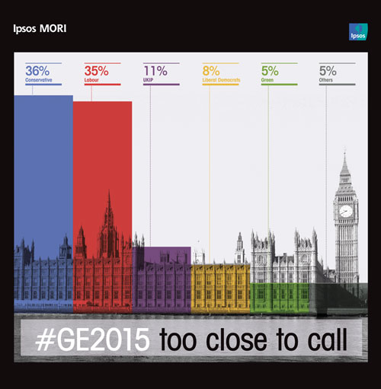Telephone polling organisations have higher costs than that of online polling organisations. They have to hire a lot of people to call up voters, as a result of this, sample quotas are usually relatively small, meaning weights have to be assigned to demographics in order to gain reliable data. Ipsos MORI predicted that the General Election would be a close call between Labour and Conservative party, though in actual fact the Conservative party won by 7%. This gives the impression that telephone polling is no more reliable than online polling as results gained there were similarly wrong

Figure 2: Ipsos-Mori Polling Results

(Ipsos-mori.com, 2015)[4].

**Final Call Predictions for the 2015 Election by Multiple Polling Organisations**

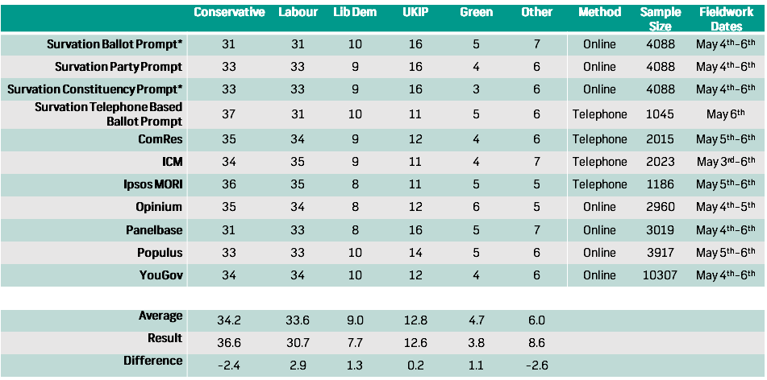

Figure 3: Final Call predictions (Survation, 2015)[6].

As you can see from the data above, there was a significant difference in the opinion polls and the actual general election results with an overestimate of 2.9% for the Labour party and an underestimate of -2.4% for the Conservative party on average.

**Comparison of Online and Telephone Polling Accuracy in the 2015 General Election**

|  |  |  |  |  |  |  |
| --- | --- | --- | --- | --- | --- | --- |
|  | Conservative | Labour | Lib Dem | UKIP | Green | Other |
| Telephone polling | 35.50% | 33.75% | 9.00% | 11.25% | 4.5% | 6% |
| Online polling | 32.86% | 33.00% | 9.14% | 14.57% | 4.57% | 6.14% |
| Result | 36.60% | 30.70% | 7.70% | 12.60% | 3.80% | 8.60% |
| Difference (Telephone Polling) | -1.10% | 3.05% | 1.30% | -1.35% | 0.70% | -2.60% |
| Difference (Online Polling) | -3.74% | 2.30% | 1.44% | 1.97% | 0.77% | -2.46% |

Figure 4: Comparison Between Online and Telephone Polling Accuracy (Survation, 2015)[6].

As you can see from the data that I calculated, online polling appeared to experience a larger percentage error than that of telephone polling, with the exception of the “Labour” and “Other” column results. This implies that during the 2015 election, telephone polling was more accurate than online polling, despite the use of larger sample sizes from online polling organisations such as YouGov. This is borne from the inaccurate weighting used by YouGov when calculating opinion poll results.

**Undecided Voters**

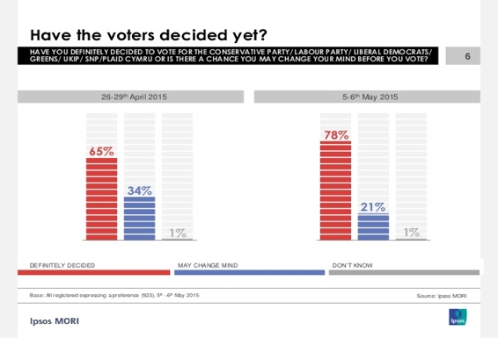As you can see from the data above collected by Ipsos MORI, of the sample of 1186 people questioned 22% were still not certain who they were going to vote for as of the 6th of May 2015 (one day before the General Election). This means a significant amount of the sample was deemed to be unreliable, hence voting intention figures were only based on 862 adults. This is small sample size cannot be

considered representative of Figure 5: ‘Have the Voters Decided Yet?’ (Survation, 2015)[5].

the UK electorate.

**Conclusion**

In conclusion, I believe that the opinion polling results of 2015 were inaccurate. They gave off the impression that the election was much closer than what was actually the case. This was a result of the combination of the incorrect demographic weights as well as the small sample sizes used in particular by telephone-polls. Furthermore, the significant number of undecided voters made predictions much more difficult to ascertain. In order to make opinion polling more accurate, adjustments of voter samples are needed to better reflect the UK’s voters. Additionally, a substantial increase in sample size for telephone polls are needed in order to improve accuracy of data gathered. Whilst opinion polling may never be 100% accurate, they are still necessary to view a rough snapshot of where the mood of the country is.

Reference List

1. BBC News. (2015). *Is it the end for telephone polling? - BBC News*. [online] Available at: http://www.bbc.co.uk/news/uk-politics-33228669 [Accessed 13 Mar. 2017].
2. Clark, T. and Perraudin, F. (2016). *General election opinion poll failure down to not reaching Tory voters*. [online] the Guardian. Available at: https://www.theguardian.com/politics/2016/jan/19/general-election-opinion-poll-failure-down-to-not-reaching-tory-voters [Accessed 11 Mar. 2017].
3. Ipsos-mori.com. (2015). *Ipsos MORI | Digital Research | Mobile Research*. [online] Available at: https://www.ipsos-mori.com/ourexpertise/digitalresearch/mobileresearch.aspx [Accessed 11 Mar. 2017].

Ipsos-mori.com. (2015). *Ipsos MORI | Poll | The Ipsos MORI Final Election poll*. [online] Available at: https://www.ipsos-mori.com/researchpublications/researcharchive/3572/The-Ipsos-MORI-Final-Election-poll.aspx [Accessed 15 Mar. 2017].

1. Shakespeare, S. (2015). *YouGov | Analysis: what went wrong with our GE15 polling and what will we do to improve?*. [online] YouGov: What the world thinks. Available at: https://yougov.co.uk/news/2015/12/07/analysis-what-went-wrong-our-ge15-polling-and-what/ [Accessed 14 Mar. 2017].
2. Study.com. (2016). *The Measurement of Public Opinion - Video & Lesson Transcript | Study.com*. [online] Available at: http://study.com/academy/lesson/the-measurement-of-public-opinion.html [Accessed 15 Mar. 2017].
3. Survation. (2015). *The General Election 2015 & The Polls – What Happened?*. [online] Available at: http://survation.com/the-general-election-2015-the-polls-what-happened/ [Accessed 14 Mar. 2017].